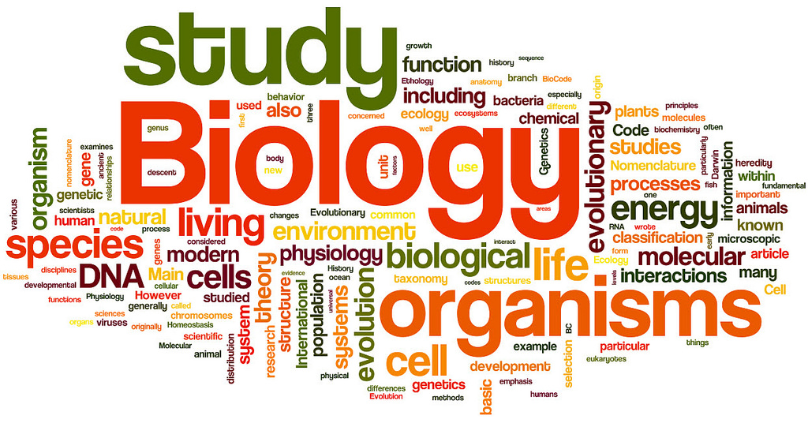

Honors Biology and Biology Summer Enrichment
Ms. Ehring and Ms. Shamdasani

Sign-up for the CK-12 website to practice your science skills over the summer. All Biology students will take the End of Course exam this year and we want you to do your best. These online assignments will help you to review information from your previous science classes and preview information for the upcoming year.

To join:
1. Go to www.ck12.org.
2. Click join to create an account, or Sign in.
3. Click Groups.
4. Click join a Group.
5. Enter code: 19yj5

You can also join the class by using this link:
https://www.ck12.org/join/group/?accessCode=19yj5

